For testing purposes, our product database starts with 5 entries: 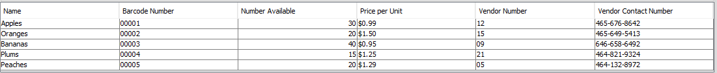

Use Case 1:

|  |  |
| --- | --- |
| Display the Main Screen | C:\Users\Chris\AppData\Local\Microsoft\Windows\INetCache\Content.Word\Capture.png |
| User presses Checkout, Checkout screen displays | C:\Users\Chris\AppData\Local\Microsoft\Windows\INetCache\Content.Word\Capture.png |
| User enters a barcode number. System fetches appropriate entry and updates the list of items appropriately. | C:\Users\Chris\AppData\Local\Microsoft\Windows\INetCache\Content.Word\Capture.png |
| Previous step is repeated until the order is complete | C:\Users\Chris\AppData\Local\Microsoft\Windows\INetCache\Content.Word\Capture.png |
| User presses checkout to finalize the order, proceeding to payment and eventually returning to the main screen to prepare for the next operation. | C:\Users\Chris\AppData\Local\Microsoft\Windows\INetCache\Content.Word\Capture.png |

Use Case 2:

|  |  |
| --- | --- |
| Display the Main Screen | C:\Users\Chris\AppData\Local\Microsoft\Windows\INetCache\Content.Word\Capture.png |
| User presses Add Product, new product page displays | C:\Users\Chris\AppData\Local\Microsoft\Windows\INetCache\Content.Word\Capture.png |
| User must enter required fields, others are optional. | C:\Users\Chris\AppData\Local\Microsoft\Windows\INetCache\Content.Word\Capture.png |
| User presses Confirm Changes, a new entry is added to the Product Database. UI returns the User to the main screen with success message. | C:\Users\Chris\AppData\Local\Microsoft\Windows\INetCache\Content.Word\Capture.png |



Use Case 3:

|  |  |
| --- | --- |
| Display the Main Screen | C:\Users\Chris\AppData\Local\Microsoft\Windows\INetCache\Content.Word\Capture.png |
| User presses Update Existing Product, Update screen displays. | C:\Users\Chris\AppData\Local\Microsoft\Windows\INetCache\Content.Word\Capture.png |
| User can double-click any field to edit the text within. The database saves this until it is restarted. | C:\Users\Chris\AppData\Local\Microsoft\Windows\INetCache\Content.Word\Capture.png |
| User presses Confirm Changes and is brought back to the main screen with a success message. | C:\Users\Chris\AppData\Local\Microsoft\Windows\INetCache\Content.Word\Capture.png |

